Step-by-Step Guidelines to Submit the Manuscript in Microsoft CMT Guidelines

Step 1 — Create a Microsoft CMT account (or log in)

1. Open the CMT login page: https://cmt3.research.microsoft.com/User/Login?ReturnUrl=%2FConferenc e%2FRecent
2. If you already have an account, click Sign in and enter your credentials.
3. If you do not have an account, click Register (or Create Account) and complete the registration form (name, email, password). Verify your email if prompted.
4. After successful registration/sign-in you will land on the CMT dashboard.
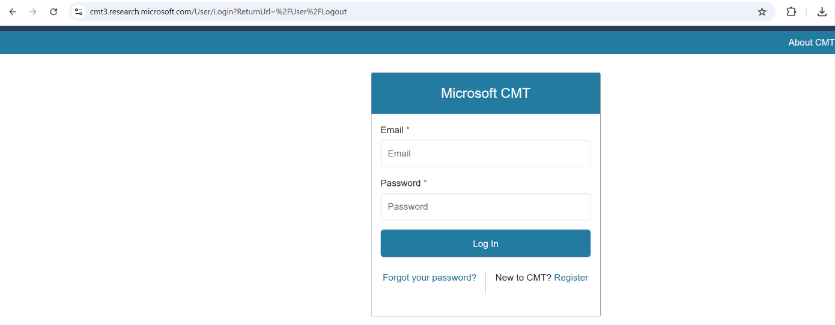

STEP 2 — Locate the conference (ICRAMIE2027)

Once you have successfully logged in, you can see the above-mentioned screen.

1. From the CMT dashboard, click All Conferences
2. In the search field, type ICAETSM2026 and press Enter.

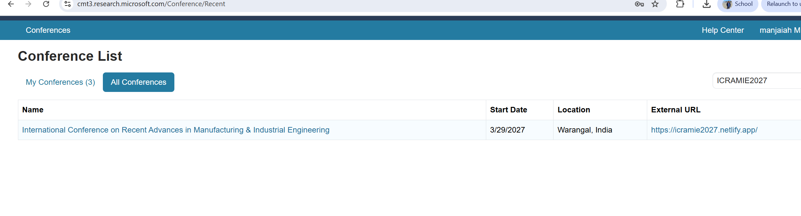

Now select the Name of the conference, by clicking on “International Conference on Recent Advances in Manufacturing & Industrial Engineering (ICRAMIE–2027)”

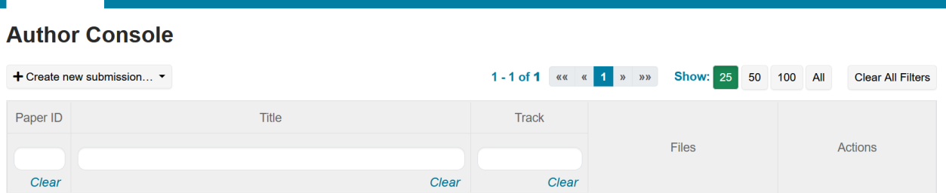

STEP 3: Start a New Submission

1. On the conference page, click Create New Submission (or New Submission).
2. Choose the correct Track for your manuscript (e.g., Full Paper, Short Paper, Poster, Workshop). Make sure you select the track that matches the paper length and topic.

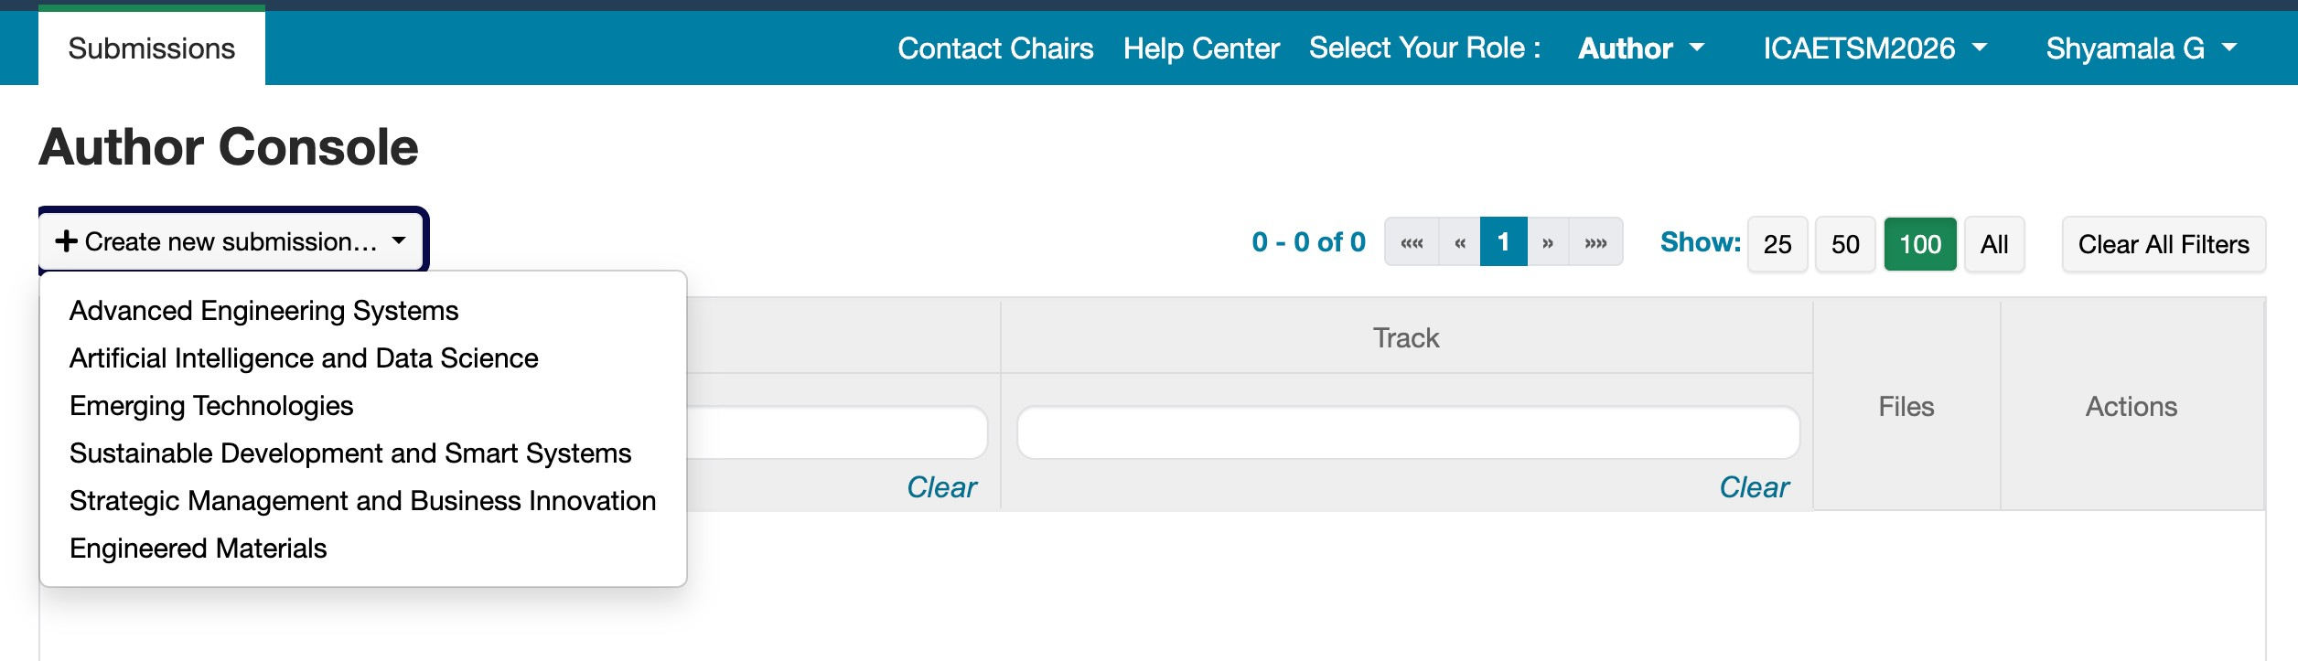

STEP 4: FINAL SUBMISSION:

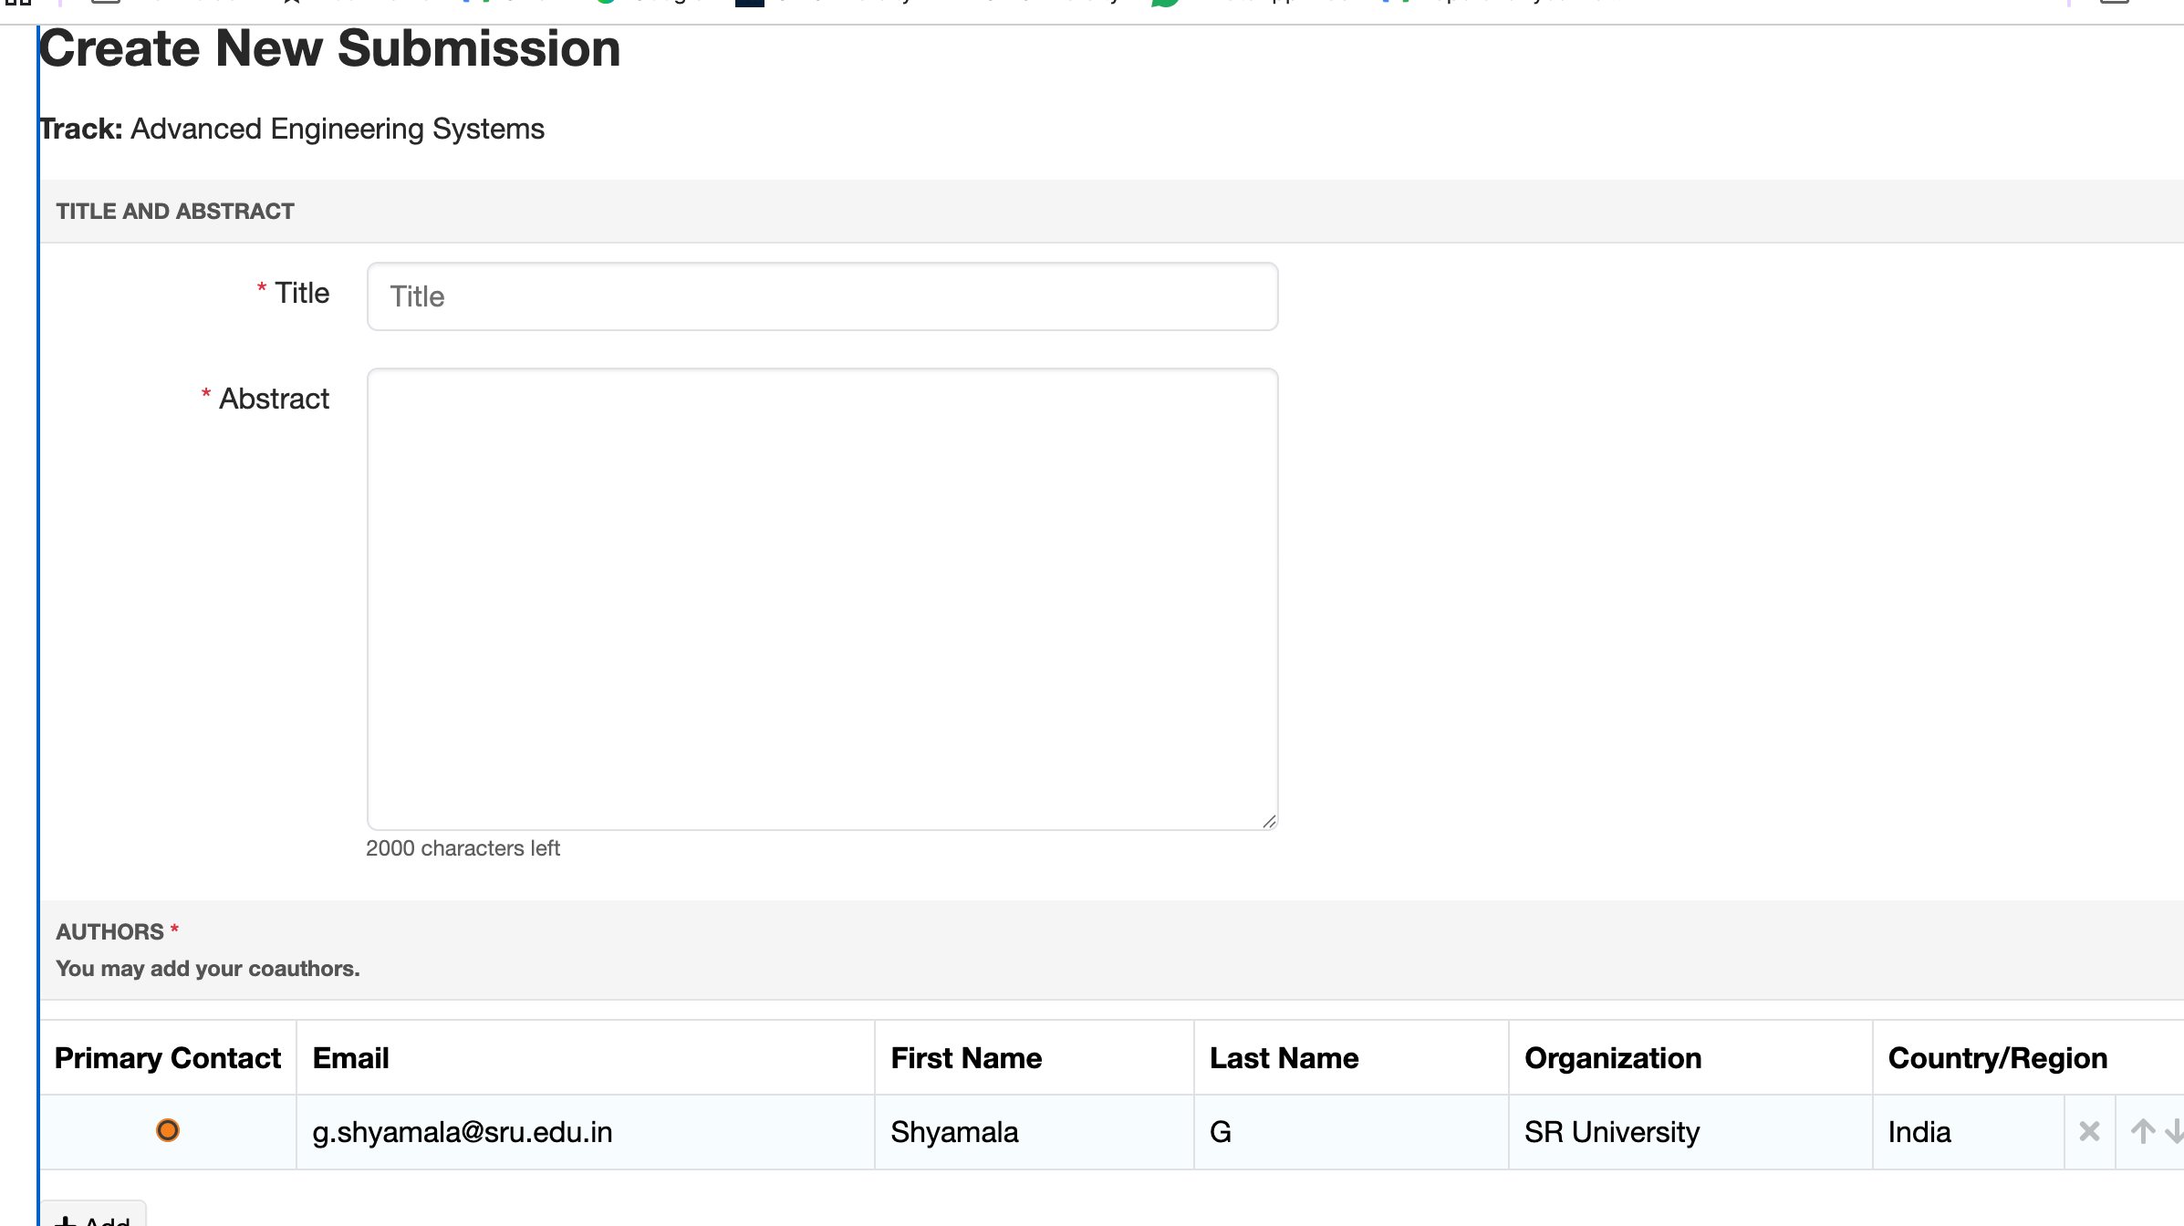Complete the form fields carefully:

1. Title: Enter the full paper title exactly as you want it to appear.
2. Abstract: Paste your abstract (follow the conference word/page limits).
3. Upload the full-length paper. Finally, click the submit button.

